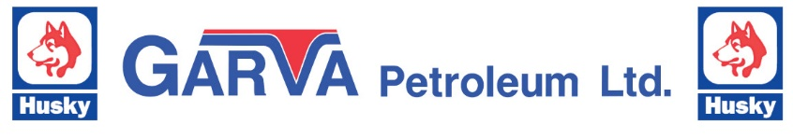
Credit Application Completion Guide

Mail to: Garva Petroleum Limited
Box 6906, Edson, AB, T7E 1V3
Email: cardmaintenance@garva.ca

To obtain a credit account with Garva Petroleum Limited, please complete the attached Credit Application and all relevant documentation, including either a completed PAD agreement or Credit Card Authorization form.

If you require access to dyed fuel products, please complete either
Form AT321 “Declaration of Tax Exempt Fuel User” for consumers other than farmers,
or an
AFFB (Alberta Farm Fuel Benefit) Application for farmers.
Links to both forms can be found on the following website:
https://finance.alberta.ca/publications/tax_rebates/fuel/ft3.html#Certificatesformarkedfuel

Every effort will be made to have application processing and credit review completed and the customer notified within five (5) business days of receipt of the completed application.

If you require fuel cards to access the Esso Key to the Highway cardlock network, please provide the following:
- The number of fuel cards required
- Fuel type(s) required: Clear Diesel, Dyed Diesel, Clear Gasoline
- Select PIN (optional)

Should you have any questions or concerns, please contact us at:
Phone: 780-712-4788
Email: cardmaintenance@garva.ca

